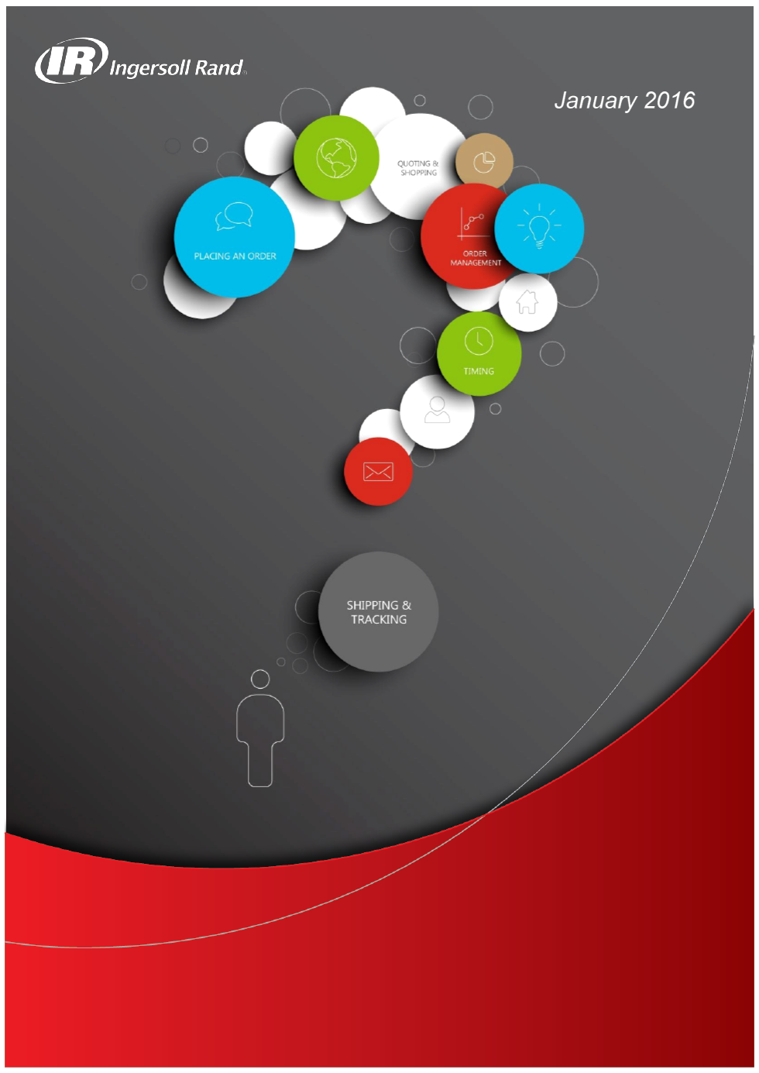
1. Access to the Store 2
2. Account set up 2
3. Express Checkout 3
4. Placing an Order or a Quote 4
5. Item Relationship and Supersession 18
6. Errors - Item not found. 19
7. The Actions Option via your Shopping Cart 19
8. “Ship To Address” and End Customer Addresses 23
9. Managing Your Order at Line Level; 25
10. How to track and trace orders 27
11. How to print invoice 32

- Access to the Store

NOTE: You need to ensure that your pop up blocker on your browser (Internet Explorer, Firefox, Google Chrome…) is deactivated.

In IR Partner you will find Region Specific Stores. Access to each store depends upon the contract associated with your account.
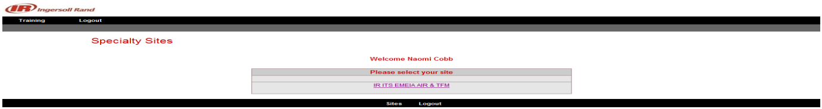
The Welcome page enables you to select your preferred language. Also, under the Profile tab the option is available for you to set up your own language and save it as preference.
From the welcome page you have quick access to the following options: Sign Out, View Backlog Report View Saved/Shared carts; View Shopping List; View Quotes and Setup Express checkout preferences.
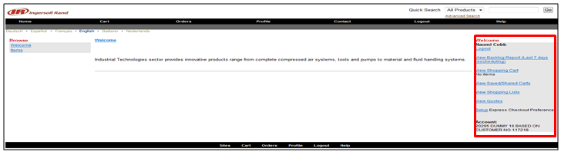

- Account set up
Default username and email address have been assigned when your User ID was created.
They can be updated on IR Partner Profile > Preferences.

From the profile menu option Personal Information you can see your personal details and modify the password and the email address.
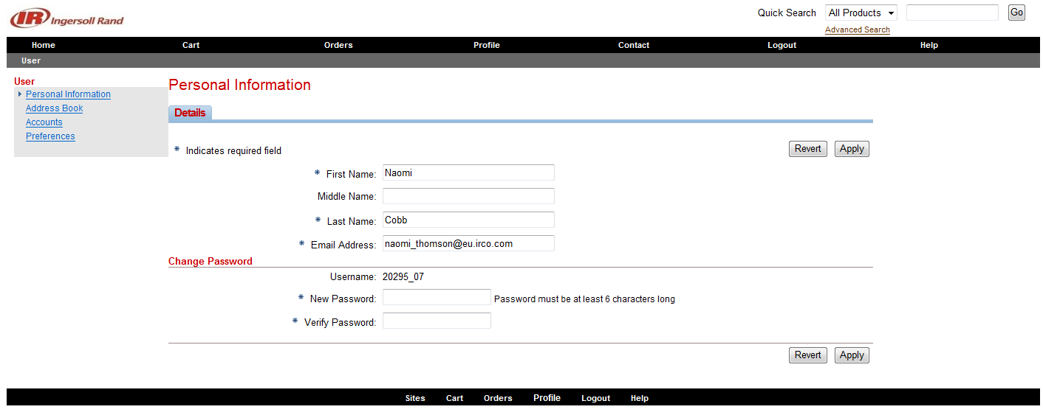
Enter the desired information into the First Name and Last Name fields.
Enter your email address in this field if it is not correct.
NOTE: In case of password recovery, the user login credentials will be emailed to email which is set up in this specific field.
Enter the desired information into the Email Address: field.
Click the Apply button. The username and Email address have been successfully changed.
It is important to keep this information up to date at all times.

- Express Checkout
Express Checkout will provide a shortcut in the checkout process and will use the default settings for ship method, Ship to address, and Order Priority. You will not be given the opportunity to ask for Order Assistance or to add any shipping or packing notes to the order.
Express Checkout must be enabled before it can be utilized. Enable Express Checkout using the Profile Menu Option > Preferences > Orders.
NOTE: Express Checkout should not be used for distributors using Sold-To Branches.
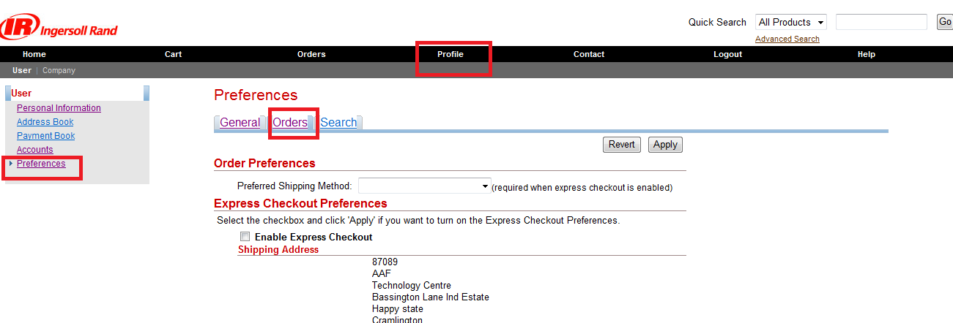
Click the box Enable Express Checkout.
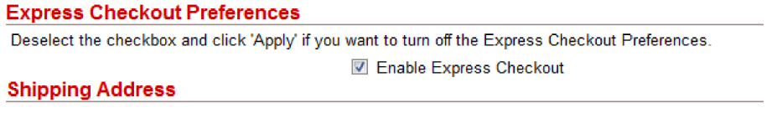
Please note; by selecting the Express Checkout option, the order will be placed and the shipping method will always be Stock. If you have any other shipping priority you need to choose the Normal Checkout option. This is discussed further on in the document.

- Placing an Order or a Quote
You can place an order or a quote by using the direct item entry process or by uploading a CSV file.
4.1 Items Entry
4.1.1 Direct item entry.
From the tool bar Menu Cart > Direct Item Entry you can enter the items number as Ingersoll Rand CPN, Ingersoll Rand Configurator Item Name (paragraph 4.3) or Ingersoll Rand Part Number manually by completing the column Item number.
Customer Part Number section should only be used by distributors who have their own references set up in IR. This can be requestor through your own customer service agent.
To proceed with the entry, you can select the option Select All or the individual line and then you can click on Fill Details.
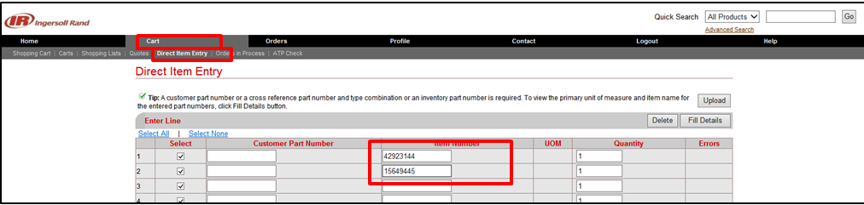
Next step please check paragraph 4.2 Fill details.
4.1.2 Items entry by using a CSV file.
The Upload option enables you to download an Excel file in CSV format. You can fill it out with the CPN details and quantities then upload it in our IR Partner site. This option helps to simplify the process and it is useful in the case of orders with multiple lines.
From the menu choose Cart > Direct Item Entry and select Upload. Then click on the Download Template link.
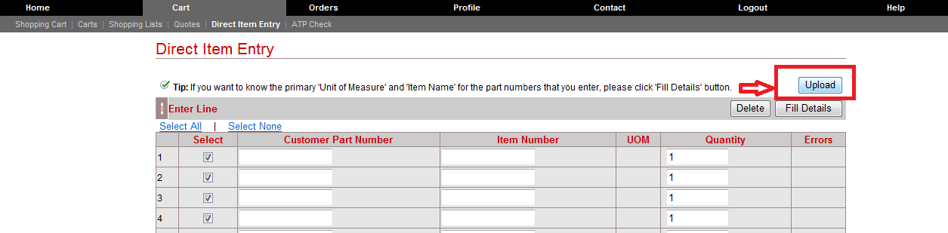
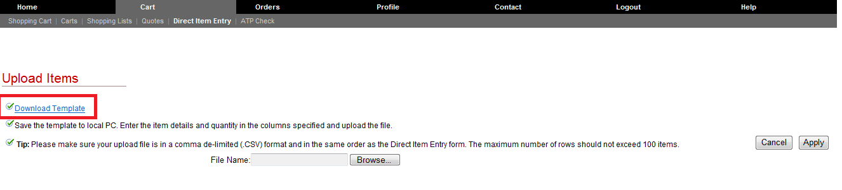
When the Excel spreadsheet is retrieved, you should fill in the columns B & D and leave the other columns blank. To save the file select CSV format.
NOTE: it’s important to save the file in CSV format; otherwise the file will be corrupted.
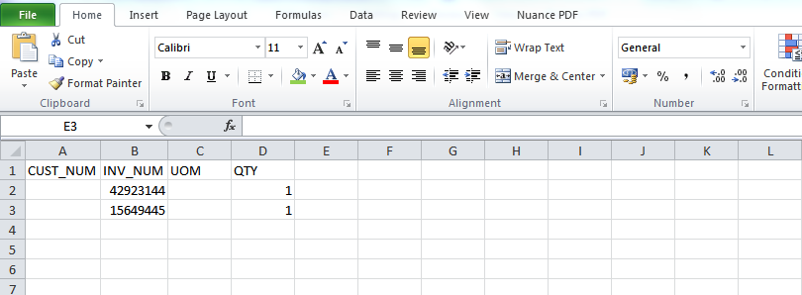
To upload the file, click on the Browse option and look up the file in your PC.
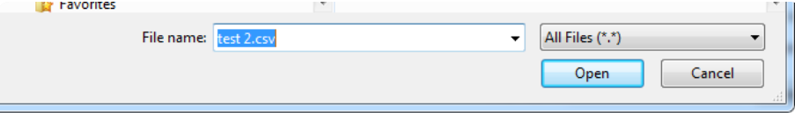
Then click on Apply.
To proceed with the entry, you can select the option Select All or the individual line and then you can click on Fill Details.
Next step please check paragraph 4.2 Fill details.
4.2 Fill details
To proceed with the entry, you can select the option Select All or the individual line and then you can click on Fill Details.
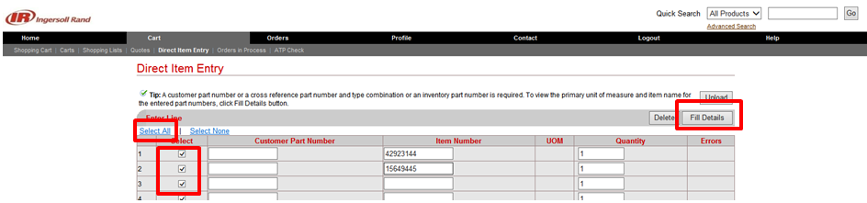
A new column will appear at the bottom of the page with the selection made. Click on the box All then click Add to Cart to continue with the submission.
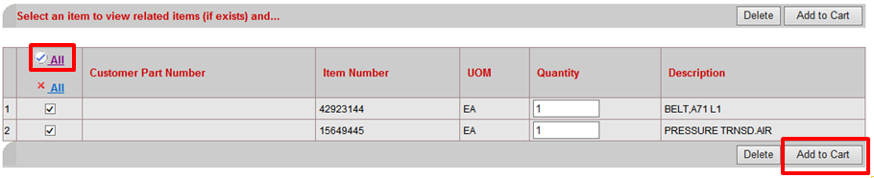
Please note. That it is possible that some items are either superseded or have related alternatives depending on your geographical location. See paragraph 5. Item Relationship and Supersession.
Or system is showing an error as Item not found. See paragraph 6. Errors - Item not found.
On the next page you have the option to add your own internal part number in the User item description field or add the Ingersoll Rand Part Number which will then be stated on the invoice and packing list.
Proceed then, to the Checkout option.
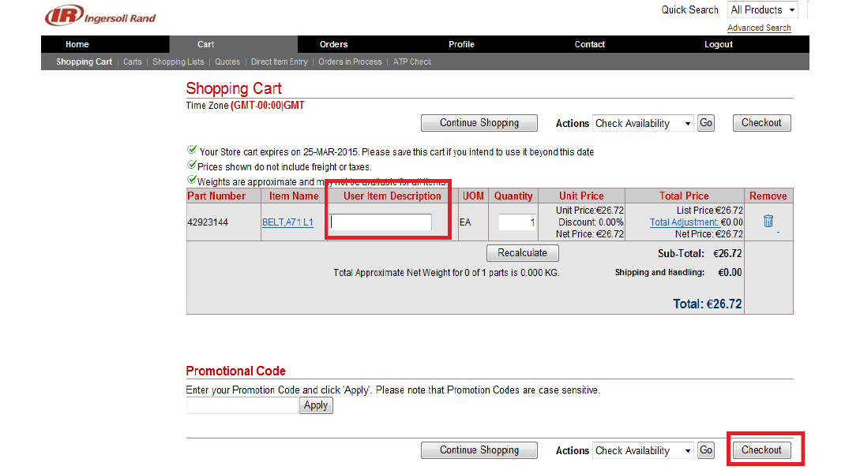
Next step is paragraph 4.4 - Checkout
4.3 The Configurator for Air Compressors
Our IR Partner configurator is for the majority for the Air compressors configuring.
If this is not a product that you normally order, then you can move on from this section, as it only applies to this specific product group.
To begin, you need the base model number of your air compressor. This is derived from the price pages of the ESA Sales Library. Bear in mind IR Partner is a global ordering system which is used across regions. Some of the base model numbers have a broader range than what you may be used to ordering.
We take the example of a UP5 15KW 10bar machine with a 500 litre receiver.
Here is what your price page will look like when you are referencing this compressor. You can see in the Configurator Item Name column your corresponding base model number for this example is UP1122.
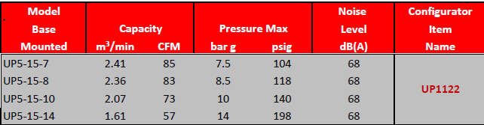
Once you have your base model number Configurator Item Name you can enter this via Direct Item Entry option. Simply click fill details and add to cart as you would for any other part number or CPN.
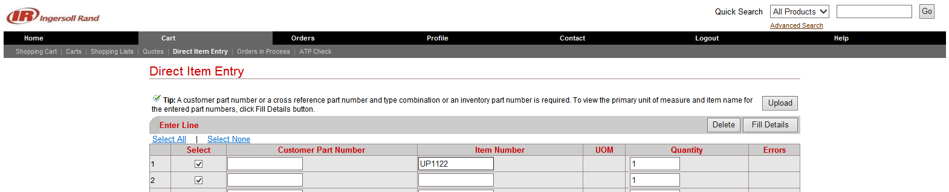
Next press Fill Details.
Next press Add to Cart.
Then, from the Shopping Cart page, click on configure.
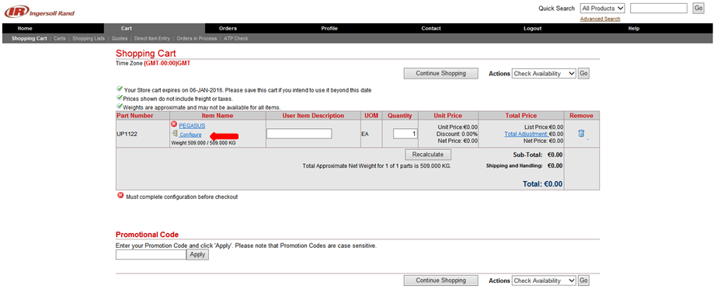
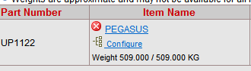
In the new page, select the options that suit your needs then click on the Preview Configuration button. Please note, that Aditional options are not standard configuration which you can choose. Special Options are not standard configuration which are not included in Aditional options. For Specials options you have to fill up Scope and supply form (SOS), which should be reviewed and approved by Engineer, before you place order.
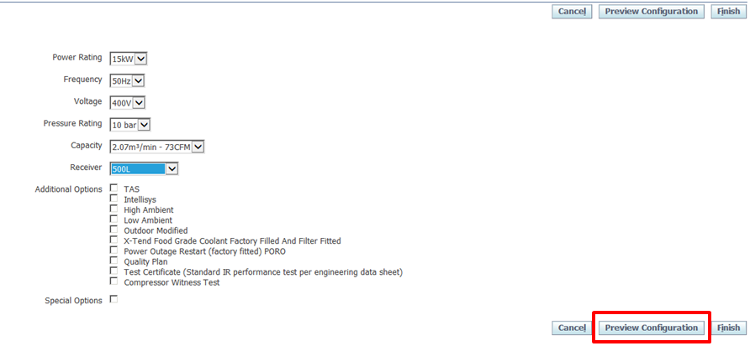
The summary with the current selection you have made, will pop up. Click on Finish to conclude and validate your selection.
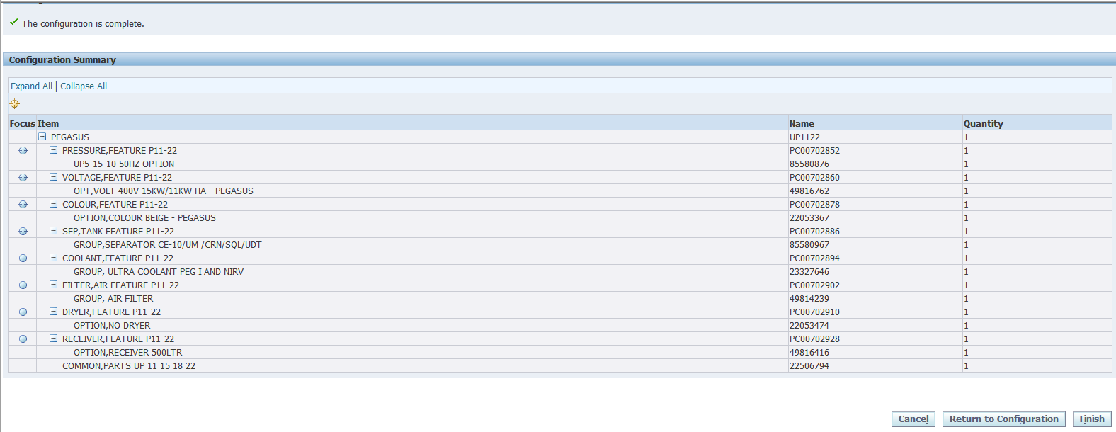
You will then be back at your Shopping Cart page. Here you will see the compessor of your choosing is displayed.
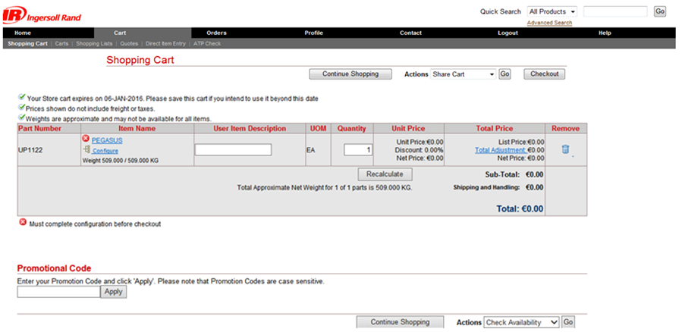
Next step is Checkout, paragraph 4.4

4.4 Checkout
To conclude with the order entry process, just follow the normal steps through the system.
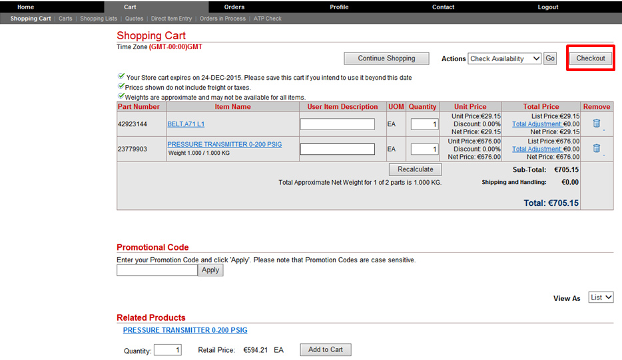
- Click Checkout.
- Click Next 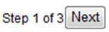

4.4.1 Shipping
Shipping Information
Under the Shipping Details column, you can change the shipping method to various options. We would suggest you choose “Best Way-Standard-TL-Ground” as the warehouse system chooses the best and fastest way automatically. The method chosen does not decide the way the goods will be shipped.
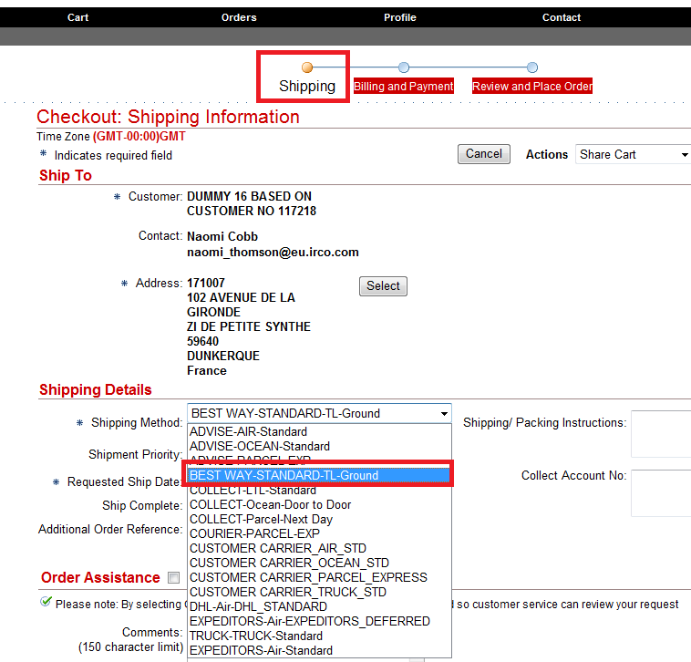
Shipment priority
The Shipment Priority field is where you choose the preferred mode of transit for your items, depending on the urgency of your requirements.

EMEIA customers, please note the following:
Standard Priority & Stock both use the same means of transport and would have the same outcome for your order in that the shipment will be sent by truck and no freight charges will be applied. The lead time would vary according to your region. Also, please bear in mind that some minimum order value charges may be applicable. If in doubt, consult your customer service representative.
Using Emergency & Priority Customer would have the same outcome on your order, in that shipping charges would be incurred. Again, the lead time would vary according to your region.
In case of an emergency, you should choose option Emergency. This will result in prioritized handling of the order and will be shipped the fastest way. You should contact the Customer Service, as this option will lead to extra charges. Otherwise, the priority should remain as standard priority.
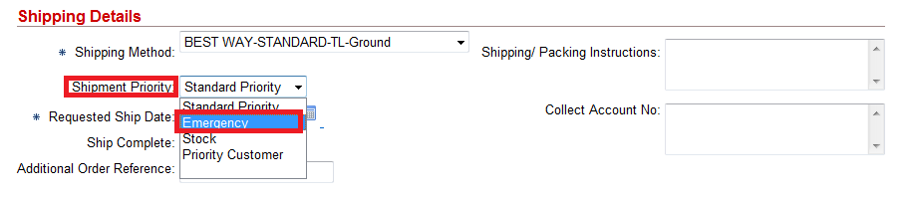

Next step is Requested Ship date
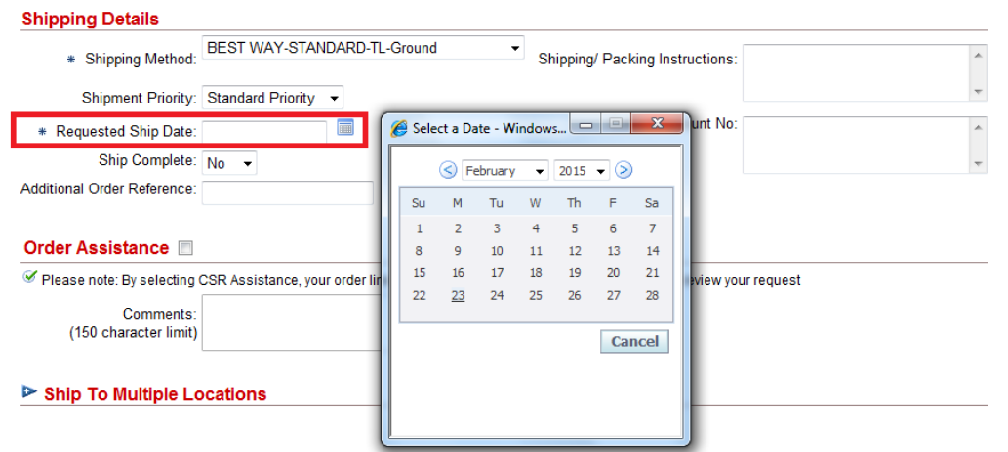
Requested Ship date is a mandatory field.
This is the date you wish for the goods to leave the IR supply site.
This not the date the goods will arrive on site.
You have to take into consideration:
Lead time or Item availability (please see paragraph 7.1.Check Availability)
- Payment day (if you have payment terms Cash in advance (CIA) or you are over Credit limit)
- Collection day (if you have EXW INCO Terms)
Based on these dates you have to choose latest and put as Requested Ship date.

Shipping/Packing Instructions

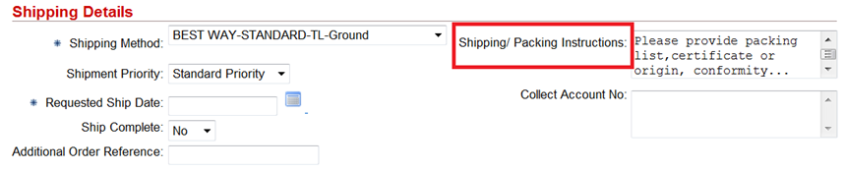
Here, you have the possibility to enter the list of shipping documents required (eg EXA, packing list, certificate of origin, certificate of conformity etc.), the contact details of your forwarder or a person in their company who should be contacted when the goods are ready.
This will be reflected in the order.
Please inform your Customer Service about your special shipping or packing request.
Ship Complete - here you have the option to choose “Yes/No”. If you choose “Yes”, then order’s lines will be consolidate, and they will be shipped only altogether, when full order will be ready.
Additional Order Reference - Reference of customer’s internal order information.
Collect Account No - field is to be used for the freight terms. You can enter your collecting account number e.g. your DHL account number.
Order Assistance - by selecting Order Assistance, your order will be placed on hold. Customer Service will review your request and action the change on the order as per your requirement and release the assistance hold so the order can proceed.
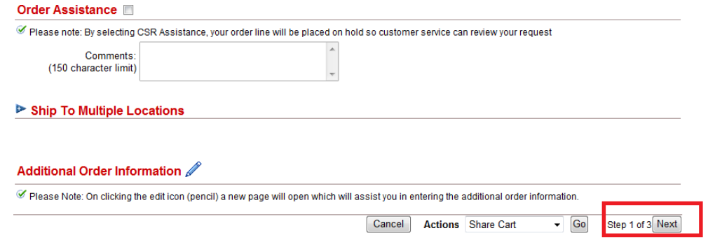
Ship to Multiple Locations - this is where you can specify the different Ship To locations for your goods. More information you will find in paragraph 8. & 9.
Additional order information option
If you have a specific Shipping Appointment Date/time requirement, please contact your customer service representative.
Please proceed to the NEXT step

4.4.2 Billing and Payment
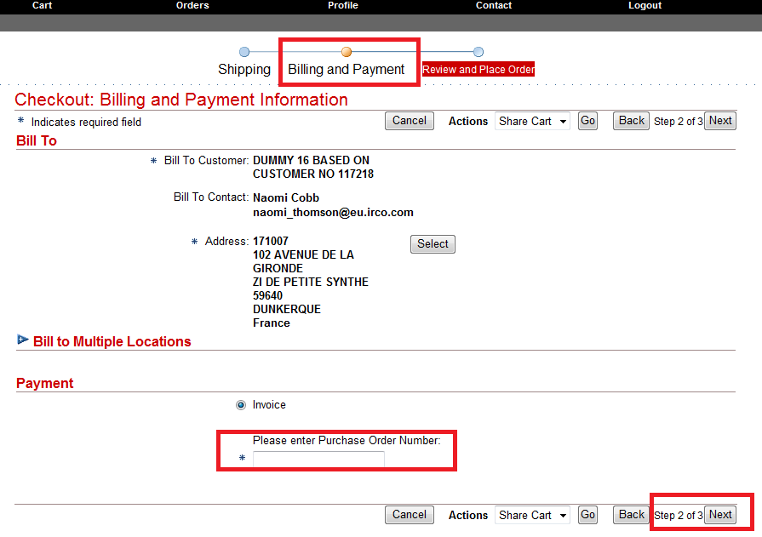
Here, you can update the Bill to address if needed.
Payment - In field for Purchase Order Number you must enter your internal order’s number.
Please proceed to the NEXT step.

4.4.3 Review and Place Order
Here, you can review the order detail before final submission.
There is an option to change again the shipping address if required. Please click on the Change button which will bring you back to the Shipping Information page.
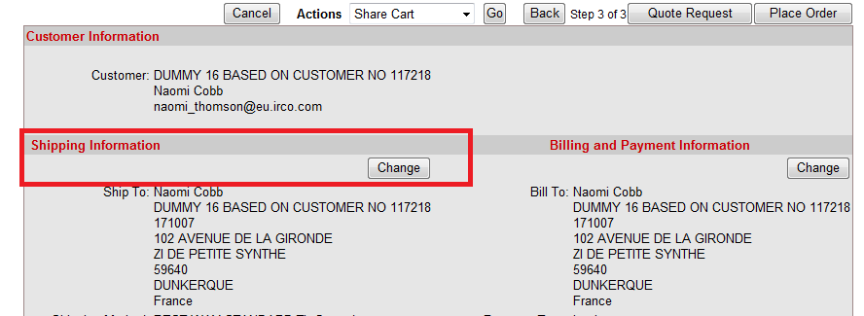
Under Order/Shipping information, you can validate again some of the shipping information entered earlier.
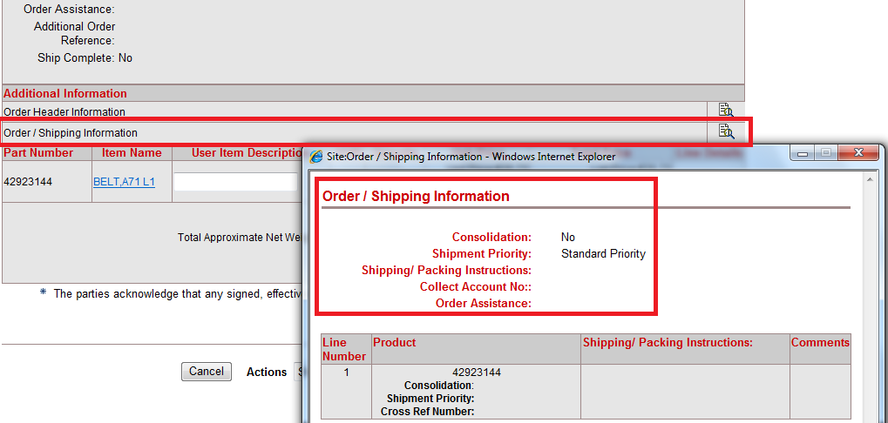
Once all details have been reviewed and finalised, please accept Terms and Conditions and click on the Place Order or Quote Request (please see instruction 4.5 Quote request) button to submit the order.
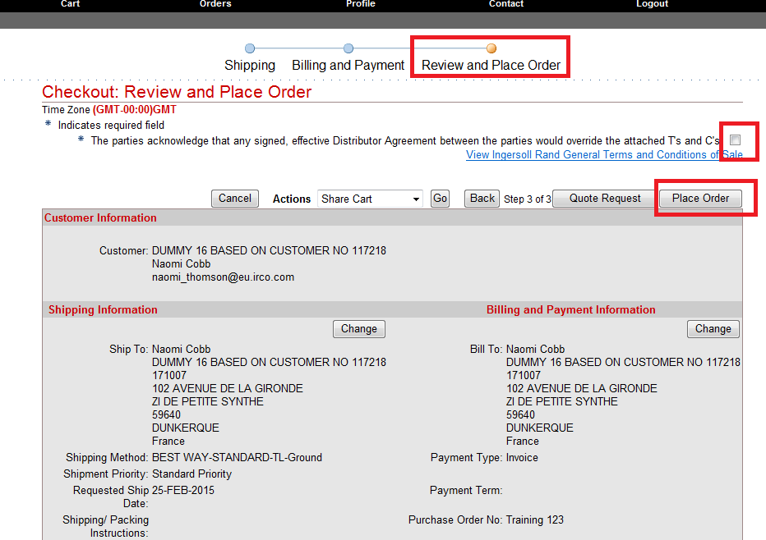
A reference number will be issued immediately to confirm the processing of the order.
As soon as the order has progressed and been booked in the system, you will receive the order acknowledgment together with the order reference number via email to the user’s email address.
All unprocessed orders can be viewed under Cart / Orders in process. Please contact your Customer Service if the order remains unprocessed or if you placed a quote. Then order or quote will be processed quicker.

4.5 Quote request

This is where you are able to register your requests for special pricing or promotions on a line of your sales order. When you have reached the Checkout: Review and Place order page below, you can begin the quoting process. This is typically referred to as SPRs, or Special Price Requests. It is a quick three step process to ensure you are invoiced at the price previously discussed with your internal IR contact. To help ensure the quote flows seamlessly into a sales order, it is helpful to attach supporting documentation to the order, for example, a copy of the email discussion that contains the price approval or a copy of the PDF flyer showing the promotion with the price quoted.
This will enable the person managing your orders to understand the basis for this request and progress your quote to a sales order without delay. How to add attachments is discussed paragraph 7.3.

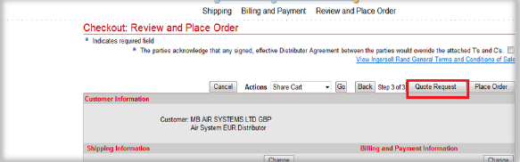
After you have ticked the box with the caption *The parties acknowledge that any signed, effective Distributor Agreement between the parties would override the attached T’s and C’s as pictured above, click on the Quote Request button.
Enter your PO reference and complete the Comments field. In the example below, the name of the promotion has been entered into the Comments field. This is a free text field for you to enter any information pertinent to the order.
The Sales Person field is not required.
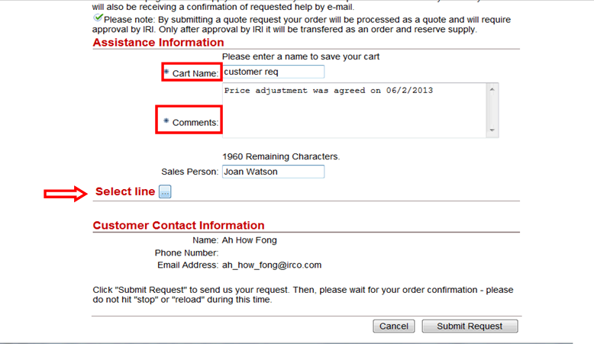
Next click on the Select line button indicated above with the red arrow. This will open a new page.
On the new page, you can tick the boxes next to the items eligible for the promotion or discount, then press the Select button indicated in the screenshot below.

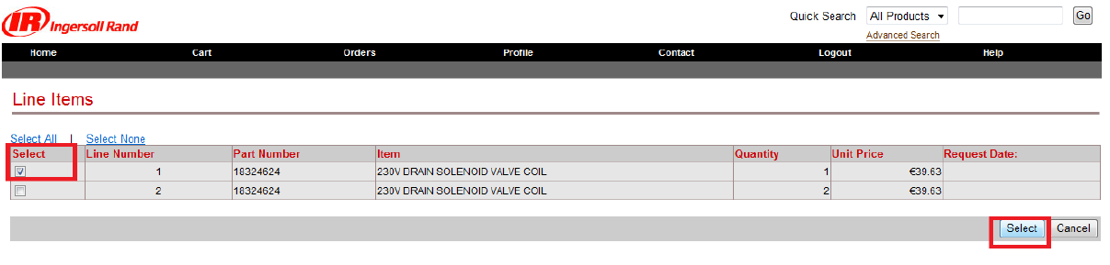

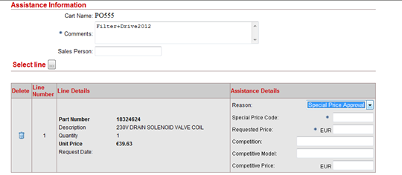
From the drop down menu, then you will select Special price approval option and indicate the Promo Code. * Please note: it is imperative mentioning the Promo code name at line level, in the field special price code*.
To finish with the submission, the customer will specify the Requested price and click on Submit Request.
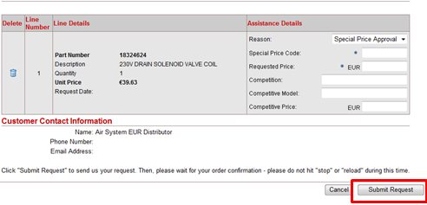
Your order acknowledgment will show the IRI quote number. To retrieve the quote from the system, just go to the Tool bar menu and select Cart and then Quotes.
Your quotes are visible under the Cart view until they have been approved by Ingersoll Rand and promoted to a sales order.
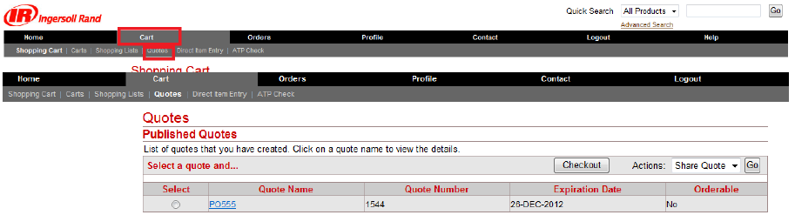
At this stage, your quote is view only.

- Item Relationship and Supersession
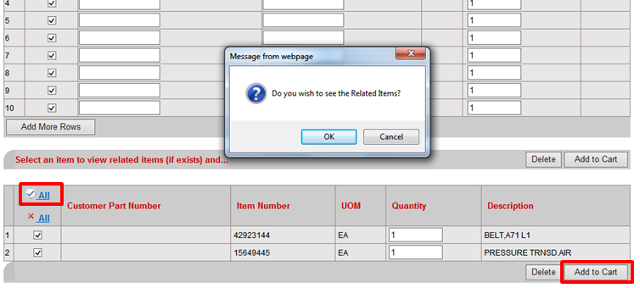
If an item has several options – which are known as Item relationships, you will be prompted to see all the related items via a pop up window while in the Direct Item Entry screen. This happens when an item is superseded / related by / to a newer version or when item numbers vary between geographical regions. Select OK and the options will then be displayed.
Please see the below example. As per the comments, the correct item to order would be 23779903. If you not sure, which item choose, please contact Parts ID or your CUSTOMER SERVICE.
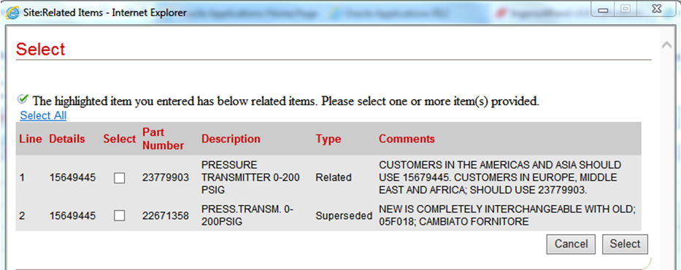
When selecting the suggested part, the system will automatically bring you back to the Direct Item Entry Screen. Then unselect not active (old) and select the new superseded item to add to your shopping cart:
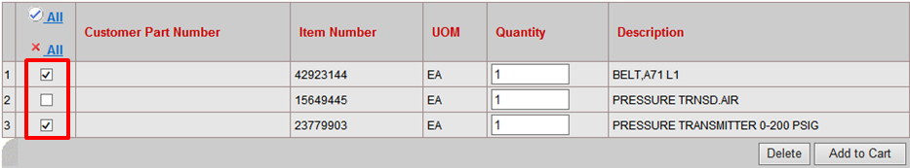
- Errors - Item not found.
Entered items, you could have error Item not found. In that case item could be Obsolete or Inactive. In those cases, you should contact your Customer Service for support or further advice.
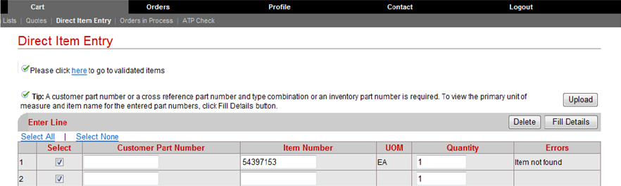

- The Actions Option via your Shopping Cart
While you are in the Shopping Cart view, you can perform the following actions in relation to a specific item you are ordering:
Check Availability
Share Cart
Save Cart
Save to list (This function enables the user to turn a cart into shopping list)
Pricing Agreements (is not in use for any of our Business Units in Industrial Technology Solutions.)
Add Attachments
Delete Cart
Direct Item Entry.

NB The option “Pricing Agreements” is not in use for any of our Business Units in Industrial
Technology Solutions.
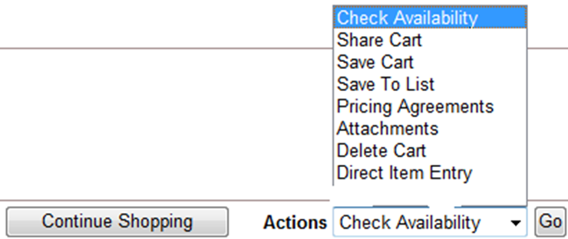

7.1. Check Availability
To check the availability of the items in the cart select Check Availability from the list.
Click the Go button.
Pay attention to the Tips listed. In this example, the tips provide a cart expiration date, information about prices and a notice for weight approximations.
The Availability Information is displayed.

Important: If the request date cannot be met and there is an emergency situation, please contact your Customer Service Representative to discuss other options that may be available.

In this example, the items are displayed as not available until 07-Oct-2014.
To accept this date, change the Needed Date field to 07-Oct-2014 and click the check availability button again to refresh.
Click the Select Date > Month > October > desired date > Check Availability button.
Needed date of the 1st item changed. Also change the 2nd item's needed date into the "earliest ship date".
The quantity now displays as available
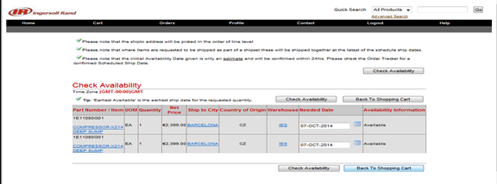

  - Sharing a Cart

In this topic you will learn how to share a cart with another user within your organization.

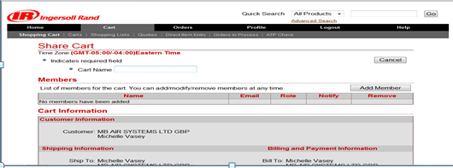
Select the Cart. To share the shopping cart, click the Actions list > Check Availability list > Share Cart > Go button.
Enter the desired information into the Cart Name (Required) field. Enter "New cart for testing".

Note: If you have already saved the cart, this step is not necessary.
Click the Add Member button.
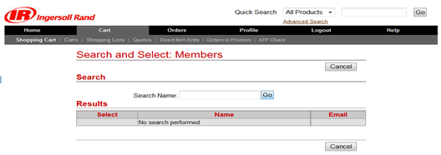

You can enter a name in the Search Name field and click the Go button to find one specific user from your organization.
In this scenario, you will leave the Search Name field blank.
Click the Go button to see all available members.

Click to select whom you wish to share the cart with. Use the Role drop down list to select the role assigned to this user. In this example you choose Administrator role.
Note: There can be only one Administrator. If you share this cart with a different role selected, you will remain the Administrator.
The Notify check box enables a notification to be sent to the email address shown.

If the check box is unchecked, no email is sent, however they will still see the cart on their Carts page. You can enter the desired information into the Comments field.

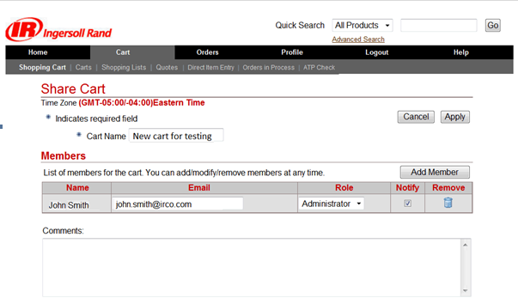

Enter the desired information into the Comments field. Enter "test". Click the Apply button.
A confirmation message is displayed. You have completed Sharing a Cart.

You will now explore how a Shared Cart is viewed.
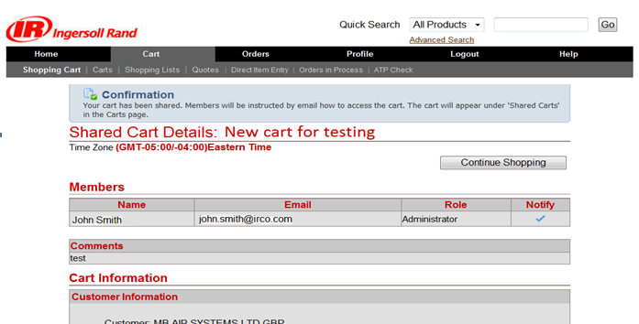

On the Carts page you can view your Saved and Shared Carts. Use the carts to compile an order for purchase at a later date.

Note: A cart will be deleted on the Expiration Date. It cannot be retrieved after this date.

  - How to add an attachment
In order to add an attachment to your cart, select Actions and from the list of values, click on Attachments.
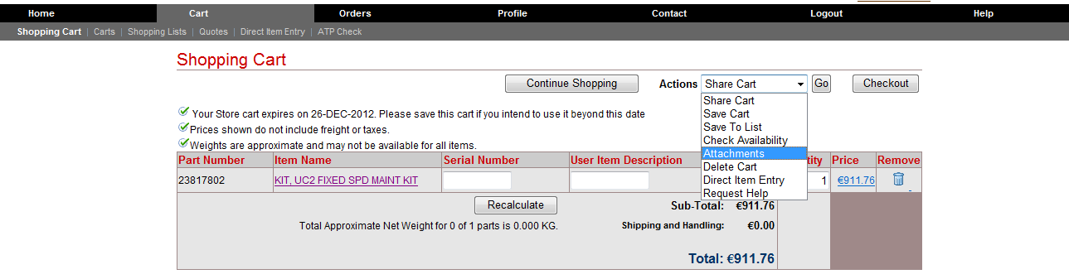
Click on Browse (This button allows you to search for the file you wish to attach on your PC’s file system), then enter a description on the field and click on Apply.
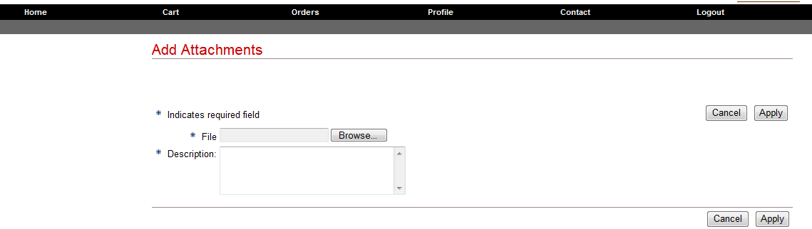
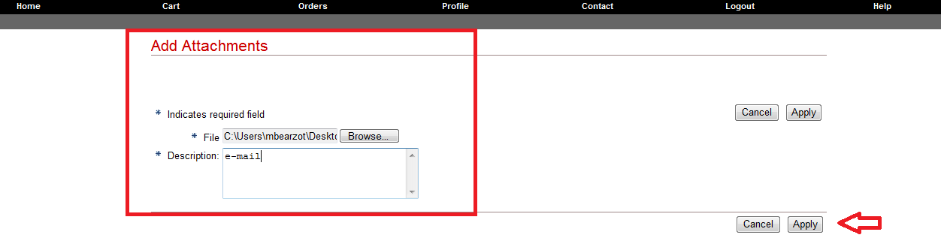
Your file should be attached to the card and will be visible by the Order Management team.
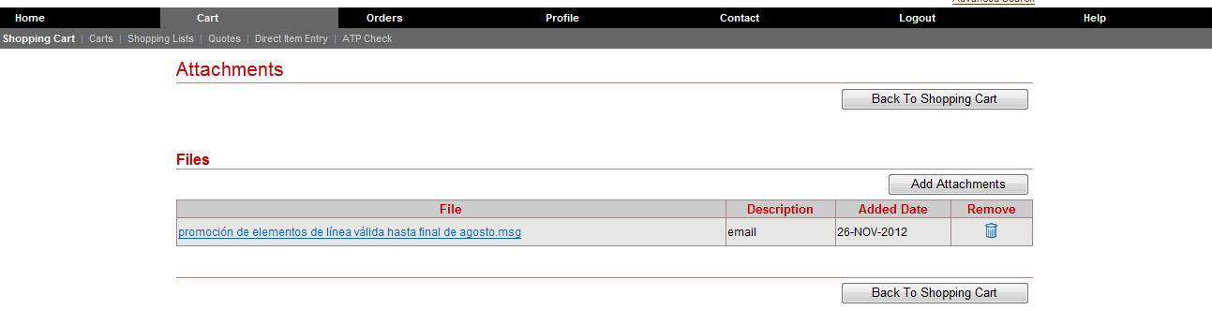

- “Ship To Address” and End Customer Addresses
If the customer wishes to have a different address against their current account set up then, they will need to select the Normal checkout process and from the Checkout > Shipping information page , click on select button beside to the Ship To Address option.
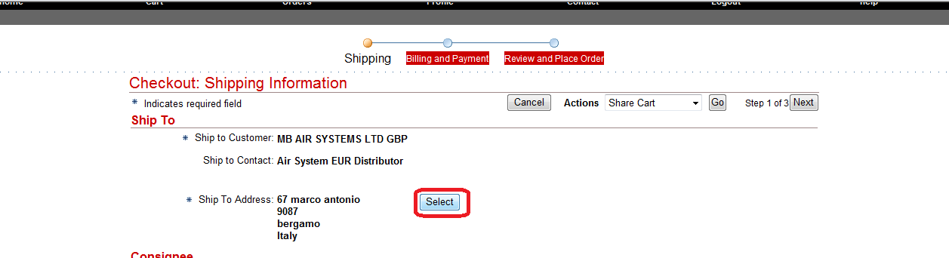

Before creating the address; the customer would have the possibility to look for an existing one.
Please note: ** when a new address is created, the system will save it. The ship to address is a permanent record; so there is no need to re-enter the address over and over. After the first entry, the address will remains in Oracle records**.
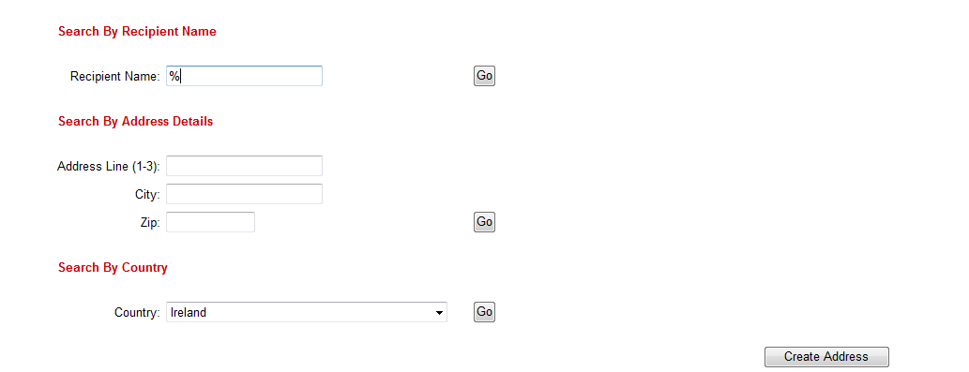
If the address is not listed, proceed with the address creation by clicking Create address tab. All the compulsory (*) fields need to be completed; then click on Apply to save the changes.
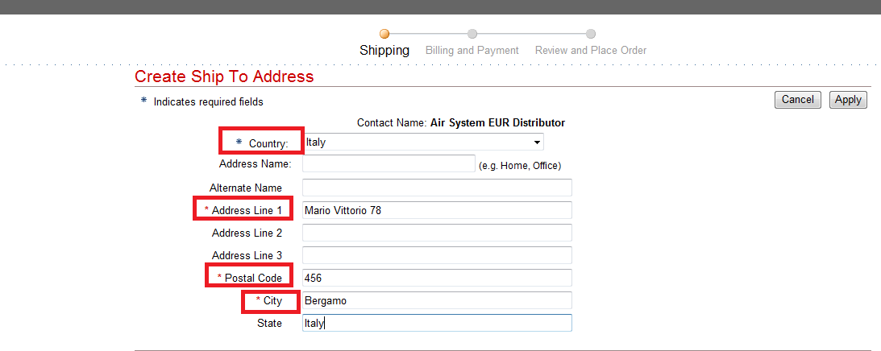
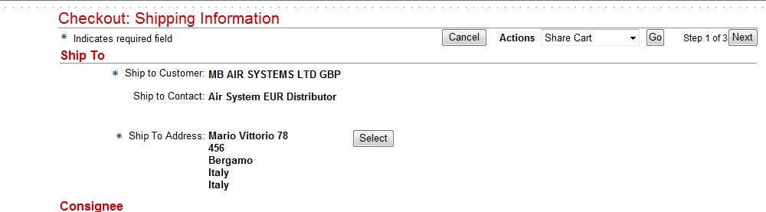
The new address will be populated.
For those distributors who wish to have only the end customer’s details showing on the packing slips and commercial invoice; the “alternate name” field (shown in the screen shot below) should be populated. In the instance where this field is populated, both the distributor’s details and the pricing will be exempt from the packing slips and the commercial invoice.

- Managing Your Order at Line Level;
- Defining your required shipping priority at line level
- CRD and splitting lines
- Consolidate your order – adding a ship set
- Shipping to Multiple Delivery Locations
- Details at line level; a last chance at editing before submitting the order
To perform any of these changes at line level follow the path: Checkout > Item Shipping Information then scroll down to the bottom of the page Ship To Multiple Location option > Ship to Multiple locations, and from the list of items, make your own selection.
Please take note of the small blue arrow. This arrow can be easily missed and is your key to opening the section.
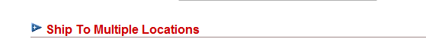
The Ship Priority field is where you choose the transit preference in rank of urgency (See paragraf 4.4.1 Shipping).
Request Date is typically defined as the earliest date at which the customer will accept the shipment. The Request Date field is where you manage your shipment dates urgency (See paragraf 4.4.1 Shipping).

Split Quantity is where you can put your request dates to work. Here you can have batches of the same item arrive at different dates and different shipment priorities. 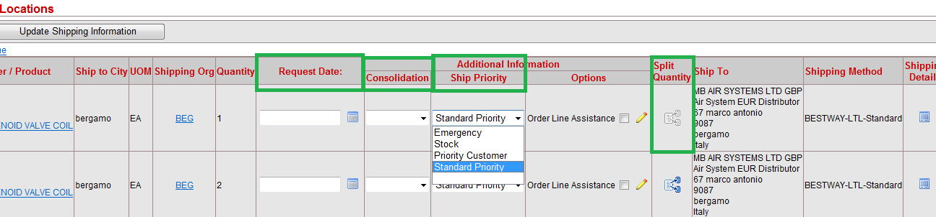
To Consolidate your order or specific lines into one delivery use the consolidation drop down box. Apply the same shipset name to the lines you need delivered together.
Ship to multiple locations: This is where you can specify the different “deliver to” locations for your goods. Tick the box on the line that will have a different address. Then click on the Update Shipping Information button, this will prompt you to make your address changes.
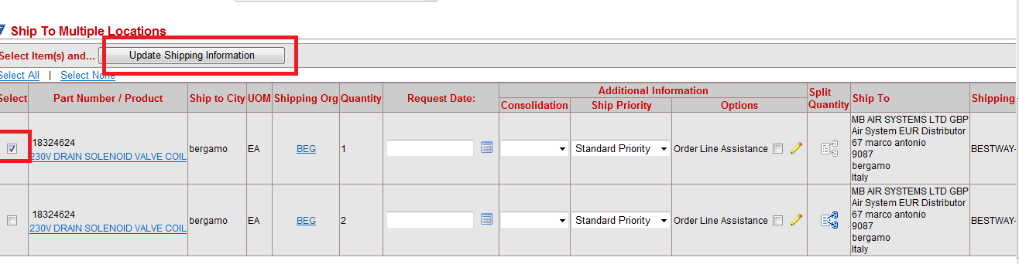
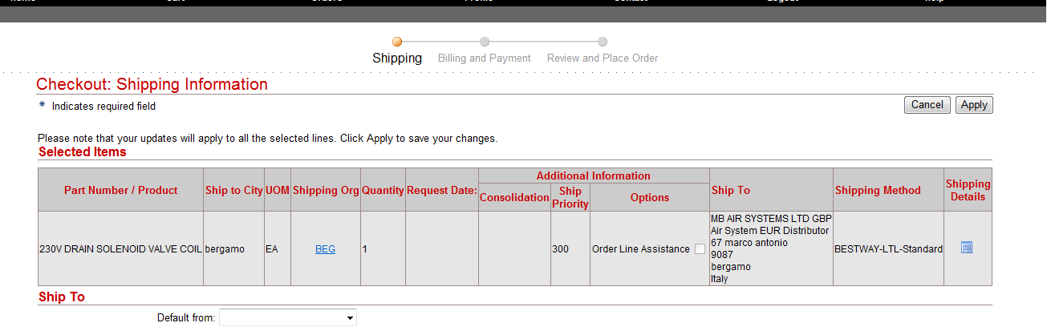
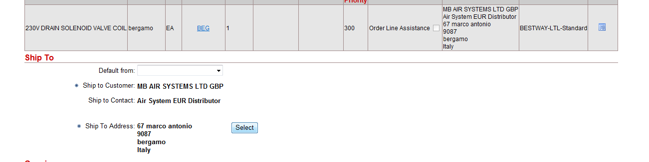
Details at line level
To review the information related to each line follow the path: Checkout >Review and Place order. The last view point of your order before submitting it is from the “magnifying glass and paper” hyperlink pictured below. Here, you can reassure yourself that the details you require have been applied sucessfully.
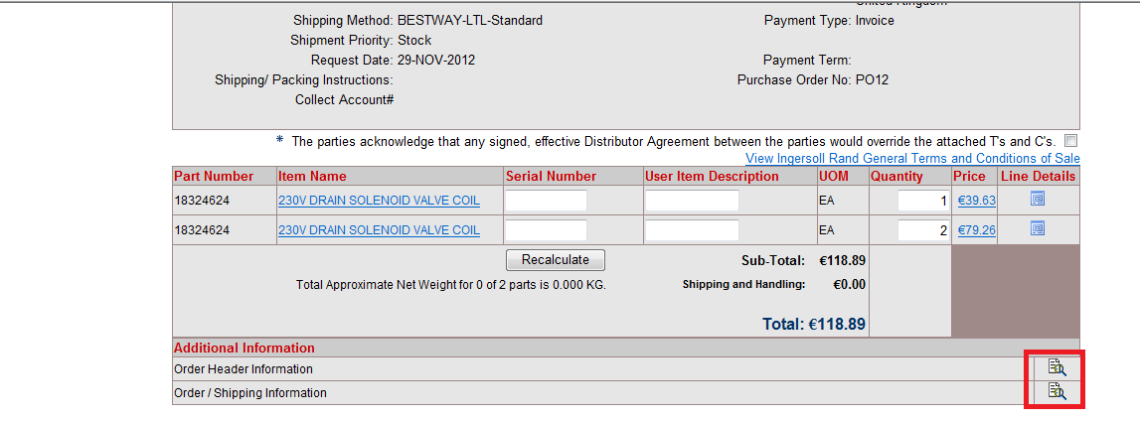

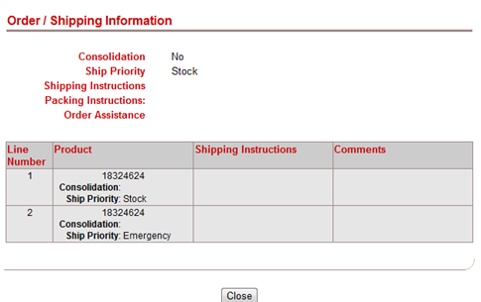

- How to track and trace orders
From the Tool bar main menu Orders, you have the possibility to track your orders using various search options and criteria. The screen shot below shows 4 search options.
Your first option has a search box, “Orders created in the last:” This box has a drop down menu where you can search for orders from the last 7 days right up to 90 days.
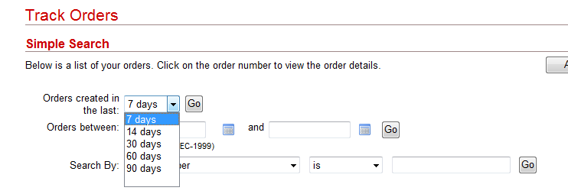
You can also capture orders within a certain date range using the “Orders between” search box. Please note dates must be entered in the following format: DD-MON-YYYY.
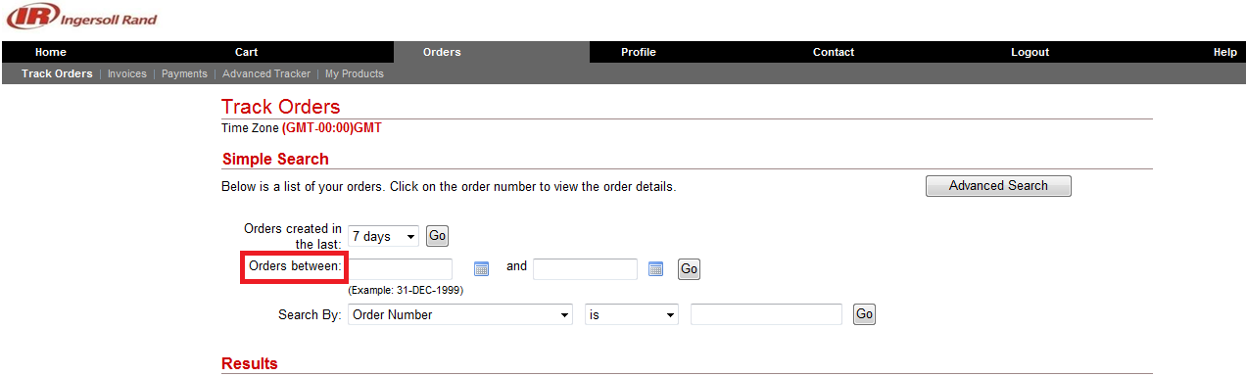
The “Search By” box offers you a drop down menu where you can search for orders by, Order Number, Reference Number, Order Date etc.
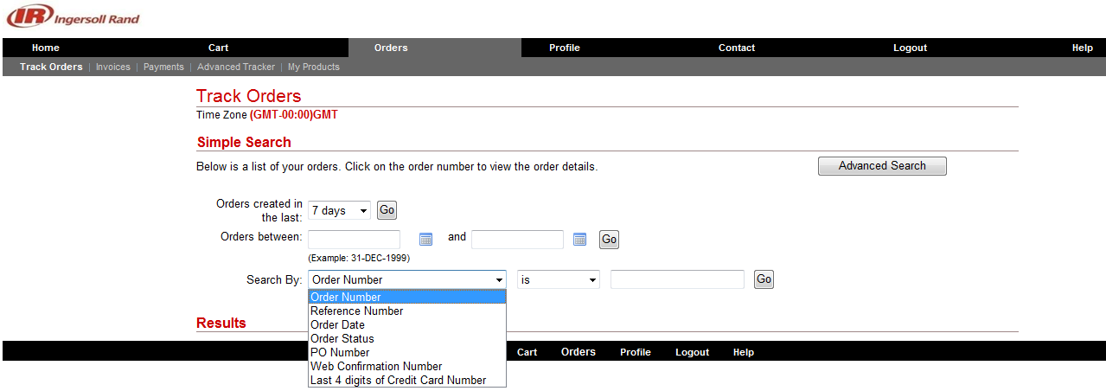
The Track Orders area also offers you an Advanced Search button. This button will take you to a new screen with additional search criteria options that may be useful.
Whatever selection you start from don’t, forget to press the Go button. To achieve your tracking result.
When the information you require has been retrieved, you can access to the order by clicking on order number hyperlink.
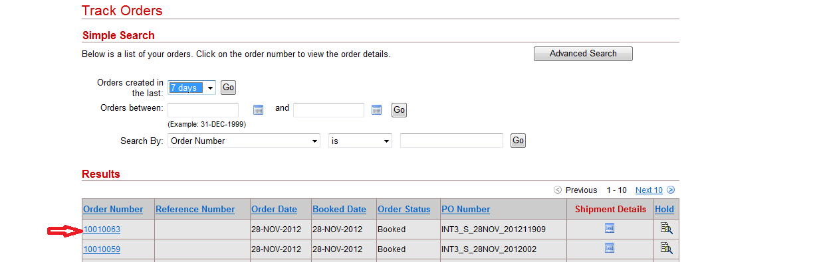
To see the status of a specific line (shipment status), you should go into the order by clicking the hyperlink and click on the Shipment Details hyperlink.
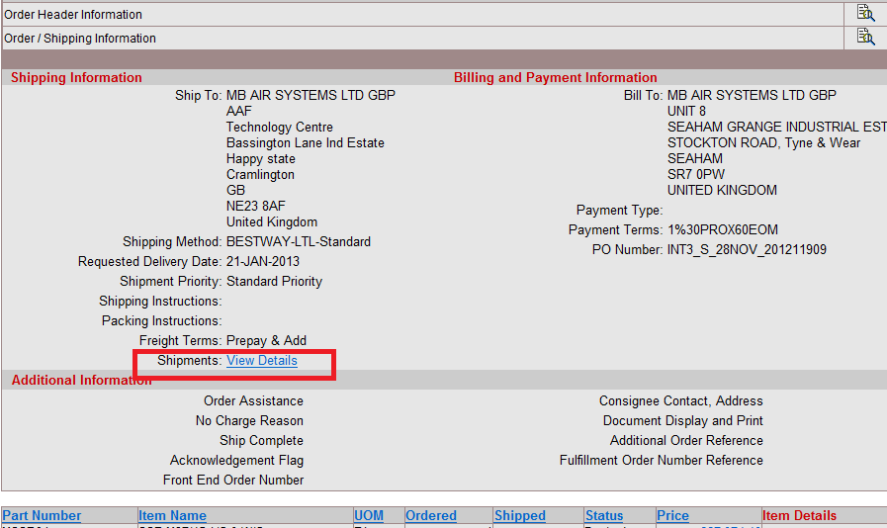
You will then have visibility into the Shipment Details. You can access shipment status information and other order details; like the tracking number.
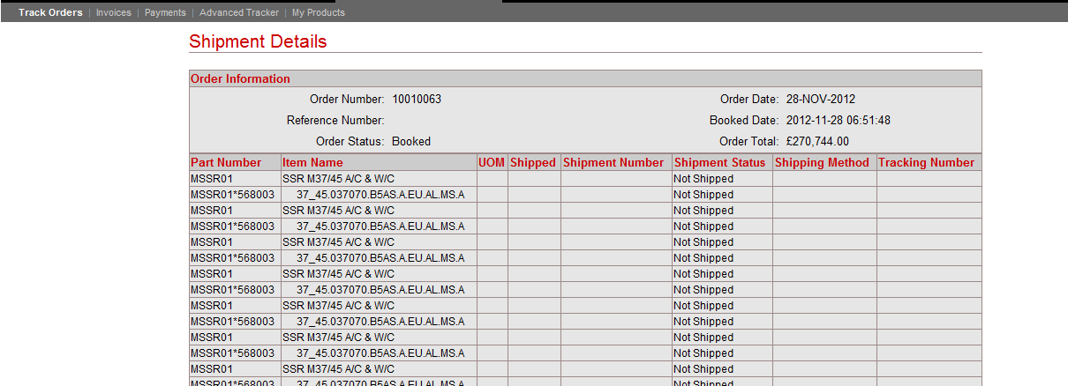

In Advanced tracker you can manage your orders
This efficient little tool offers you 4 easy to follow steps to manage your orders according to your own customized preferences.
Step #1: First you customize your preferences. You only need to do this once. All subsequent queries will use the initial preference selections as default. 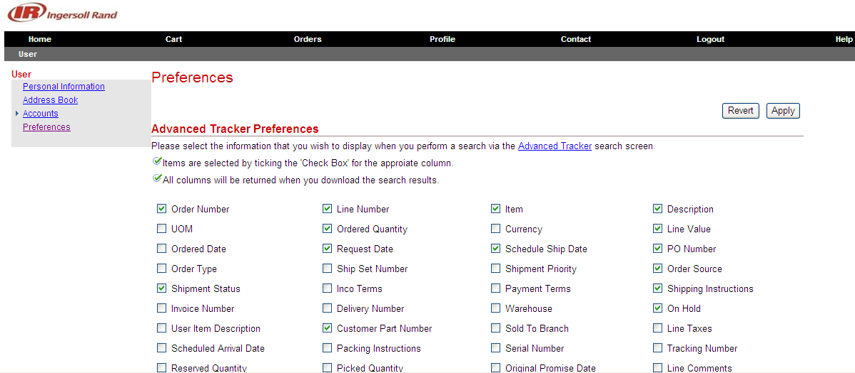
You can always re-define your set of preferences to give you more, or less, information by using the hyperlink on the word “here” indicated by the red arrow below.
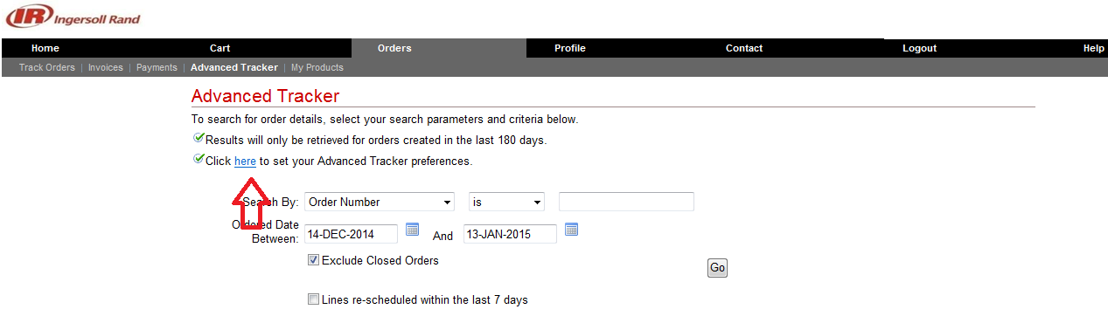
Step #2: Once your preferences are set you now enter the search criteria you want to capture. For example you may wish to search by your purchase order number or by the Ingersoll Rand sales order number.
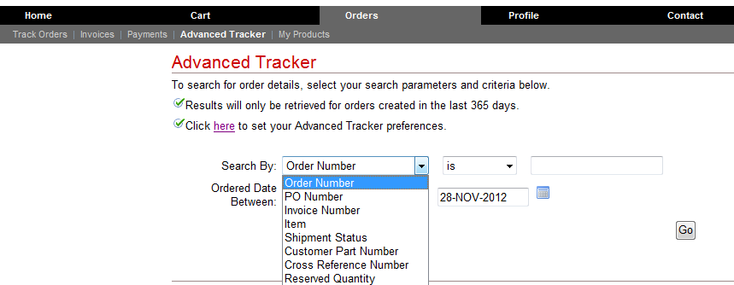
Step #3: Here you choose the dates you want to capture and press Go button.
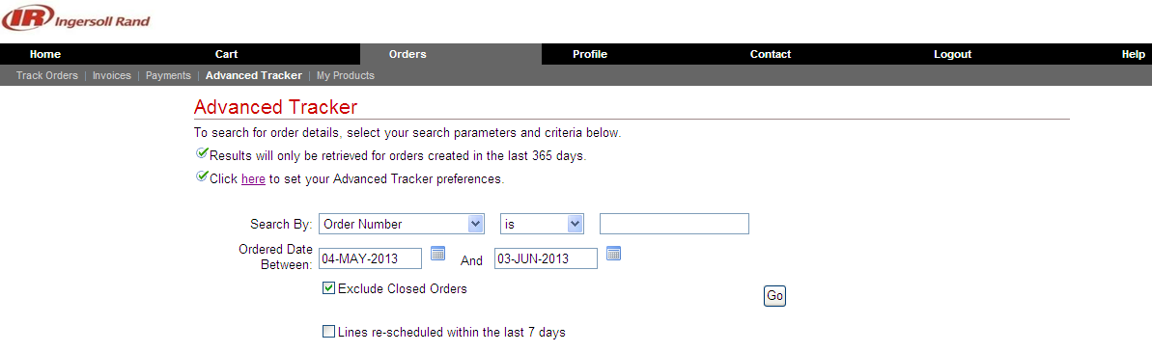
Step # 4: Here is an example of the report that you have now run. You can click on the excel spread sheet icon to download your results into an excel spreadsheet. This will make the data easy for you to manipulate, whereas the format in the screen shot is “ready only”.
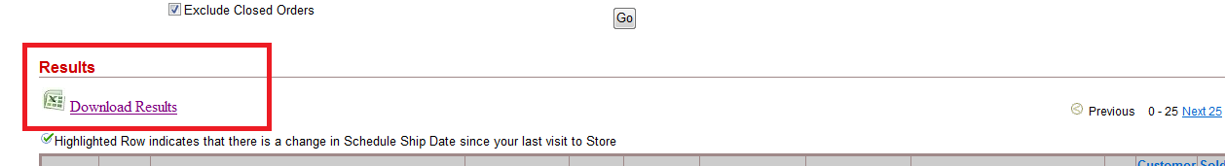

Note:
- For searches that return more than 10 results you can click the Next hyperlink to view the next 10 matches.
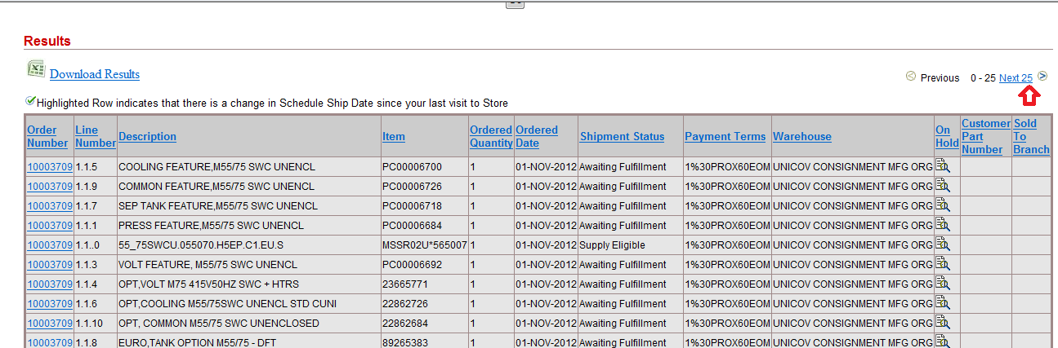
- Click the order number hyperlink to view the order details. 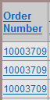

- How to print invoice

Invoices can only be printed for lines that have a shipment status Closed. The shipment status of your line is visible in the shipment in the Shipment Status and is cross referenced by the line number on the report below. Below you will see an example of an order with a status Cancelled.
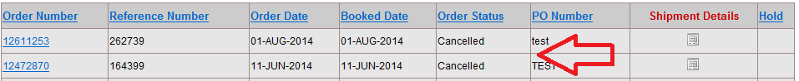
Go to the orders section on your tool bar, and then click on the invoices section as indicated by the red arrows below.
This will show criteria to allow you to capture and print specific invoices which you wish to view.
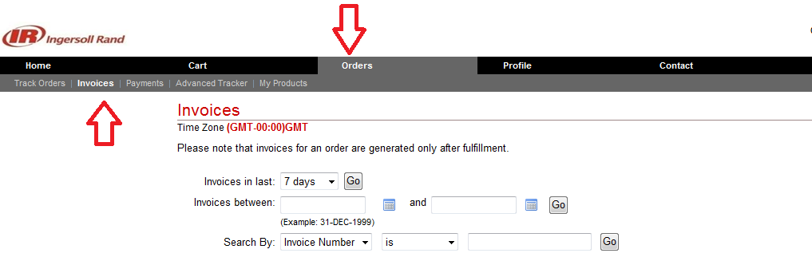

On the results screen, the Advanced Tracker fields to display are selected by using the option shown on screen.
Note: This process only needs to be performed once, unless additional information is needed.

Click the here link.

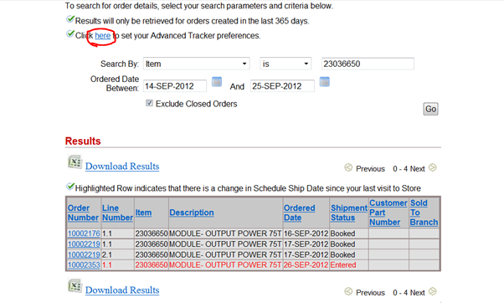
Select the fields you wish to be displayed on the results page.
Suggested fields are: Order Number, Line Number, Item, Description, Ordered Quantity, Scheduled Ship Date, PO number, and On Hold.

All fields will be included when Advanced Tracker information is downloaded to an excel file.
