A few ways to determine if a lubrication/piston pump has a 2” or 3” air motor, visually.

- PN# LM2305A-XX-B (3” air motor)
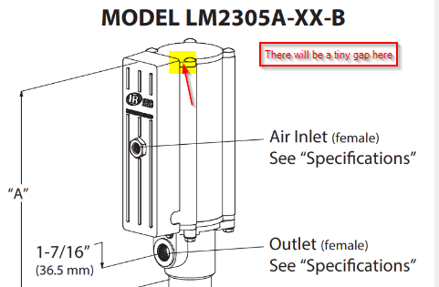
There will be a tiny gap here

- PN# LM2203A-XX-C (2” air motor)
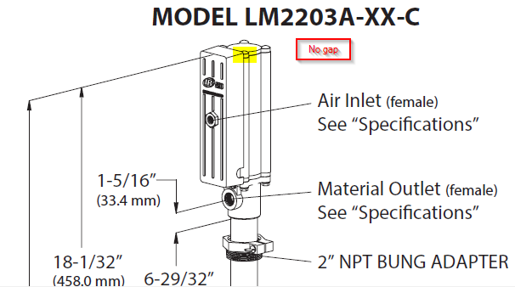
No gap
2” Air Motor
Notice that you can’t see the motor popping out behind the faceplate on this one.
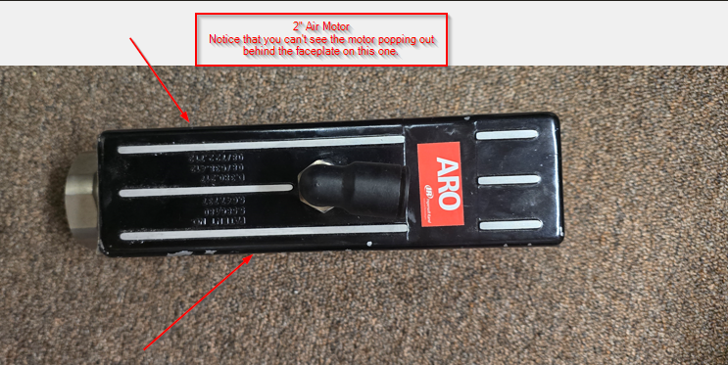
3” Air Motor
Notice the rounded edges of the air motor popping out from behind the faceplate.
